SD MAINTENANCE APPLICATION
User Manual
Step-by-step guide for business users: masters, SD transactions, Excel uploads, reports, notifications and access rights.

Item | Detail
Application | SD Maintenance Application, Version 1
Document version | 1.0
Date | 27/09/2026
Prepared for | SD Maintenance Business Team
Status | Draft for UAT

Screenshots show sample data (fictional landlords and leases) from a demonstration environment.

Contents
1. Introduction
2. Getting Started
3. Working with Screens
4. Masters
5. SD Transactions
6. Reports
7. Administration
8. Troubleshooting
Appendix A. Excel Upload Columns
Appendix B. Dropdown Values
Tip: Section numbers here match the headings. In Word, the navigation pane (View > Navigation Pane) lists every sub-section.

1. Introduction

1.1 About the application
The SD Maintenance Application is a central web system for maintaining Security Deposit (SD) and lease information. It replaces Excel-based tracking with:
- master data for cost centers, locations, users and SD records;
- SD transactions (Paid, Transfer, Adjustment, Refund) recorded against each SD Code;
- automatic calculation of SD Balance and SD Balance Repayable;
- Excel templates, bulk upload with validation reports, and export;
- email notifications for status changes and upcoming lease dates;
- access control by User Rights and a full audit trail.

1.2 Who should read this manual
Business users who maintain SD data, finance users who record and reconcile SD transactions, and administrators who manage users and access.

1.3 Conventions
Item | Convention
Dates | Always DD/MM/YYYY, for example 05/04/2024.
Amounts | Indian grouping with two decimals, for example 1,50,000.00. You can type amounts with or without commas.
Mandatory fields | Marked with * on every form.
Master status | Cost centers, locations and users are Active or Inactive. Only Active values can be chosen for new records.
SD statuses | Landlord Status and Building Status are Active or Passive.
Financial Year (FY) | April to March, written as 2024-2025.

Codes are generated by the system and cannot be edited:
Record | Code format | Example
Cost Center | CC + 4 digits | CC0003
Location Level 1 / 2 / 3 | L1- / L2- / L3- + 4 digits | L3-0008
SD record | SD + 6 digits | SD000001
SD transaction | TXN + 7 digits | TXN0000012

2. Getting Started

2.1 Logging in
- Open the application address given by your IT team in a web browser (Chrome or Edge).
- Enter your User Name and Password.
- Click Login. The Dashboard opens.
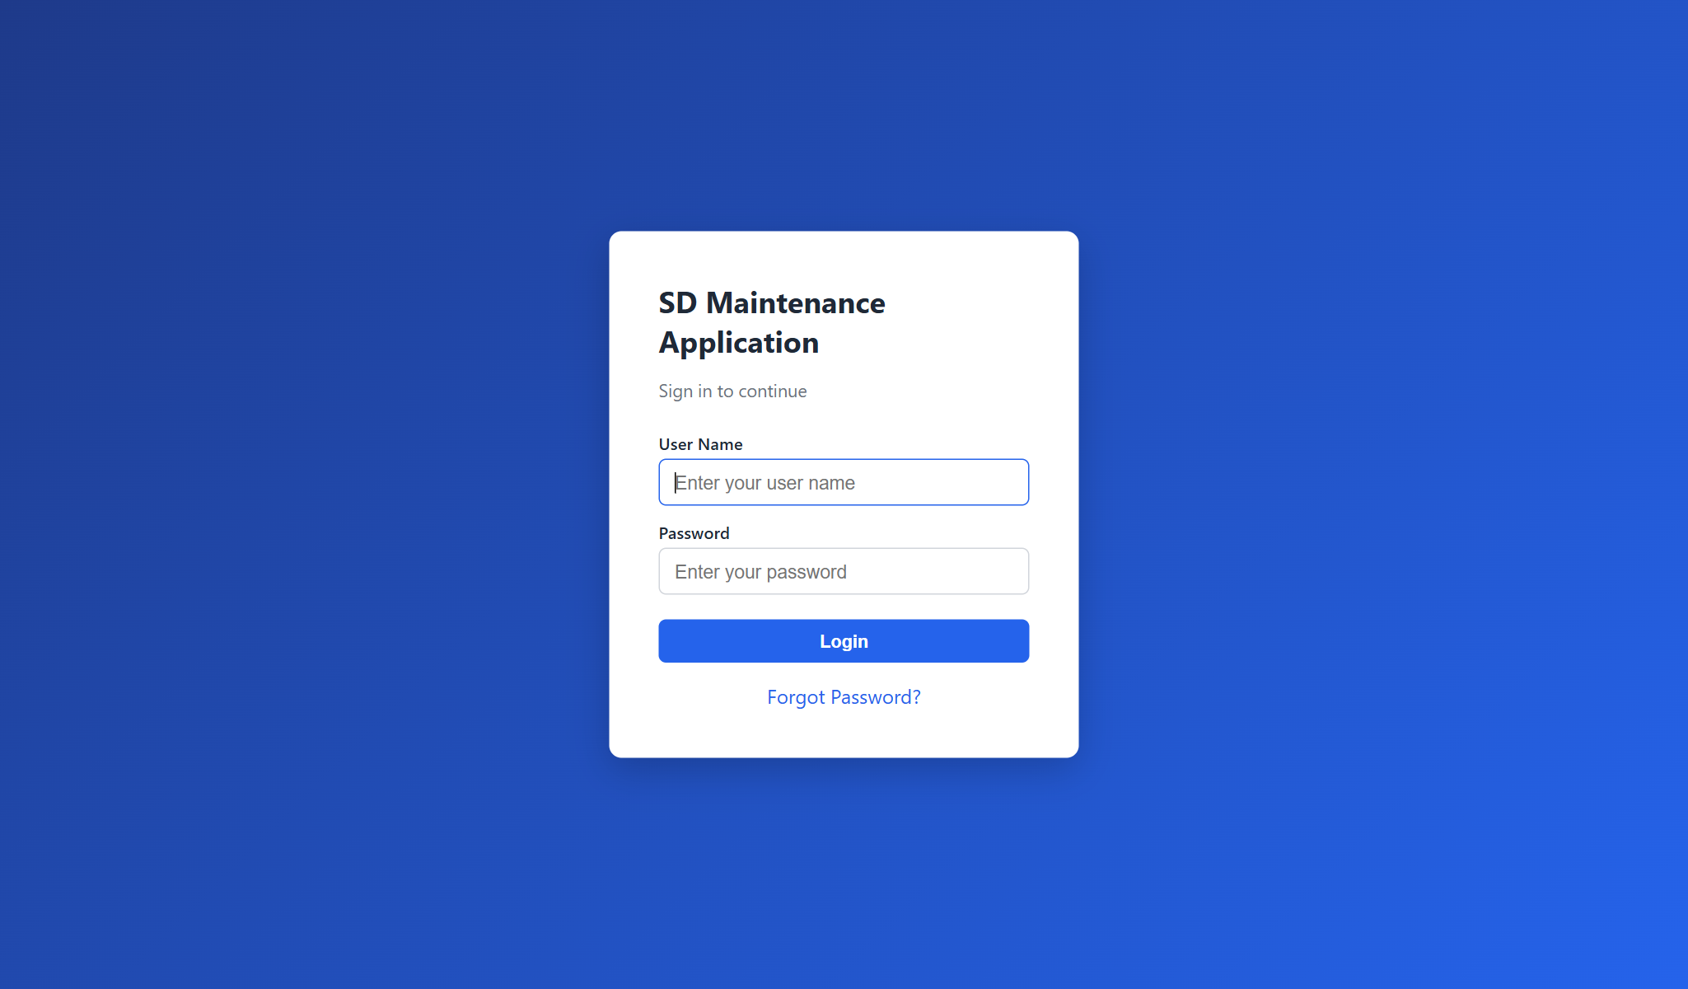
Figure 1: Login screen
Only users whose status is Active can log in. If you see "Your account is inactive", contact your administrator.

2.2 Forgot password
- On the login screen, click Forgot Password?
- Enter your registered email address and click Send Reset Link.
- Open the email and click the link. It works once and expires after 30 minutes.
- Enter and confirm your new password, then log in with it.
Note: Passwords must be at least 8 characters and contain at least one letter and one number.

2.3 Dashboard and menu
The Dashboard shows a card for every screen you are allowed to open. The same screens appear in the menu bar at the top.
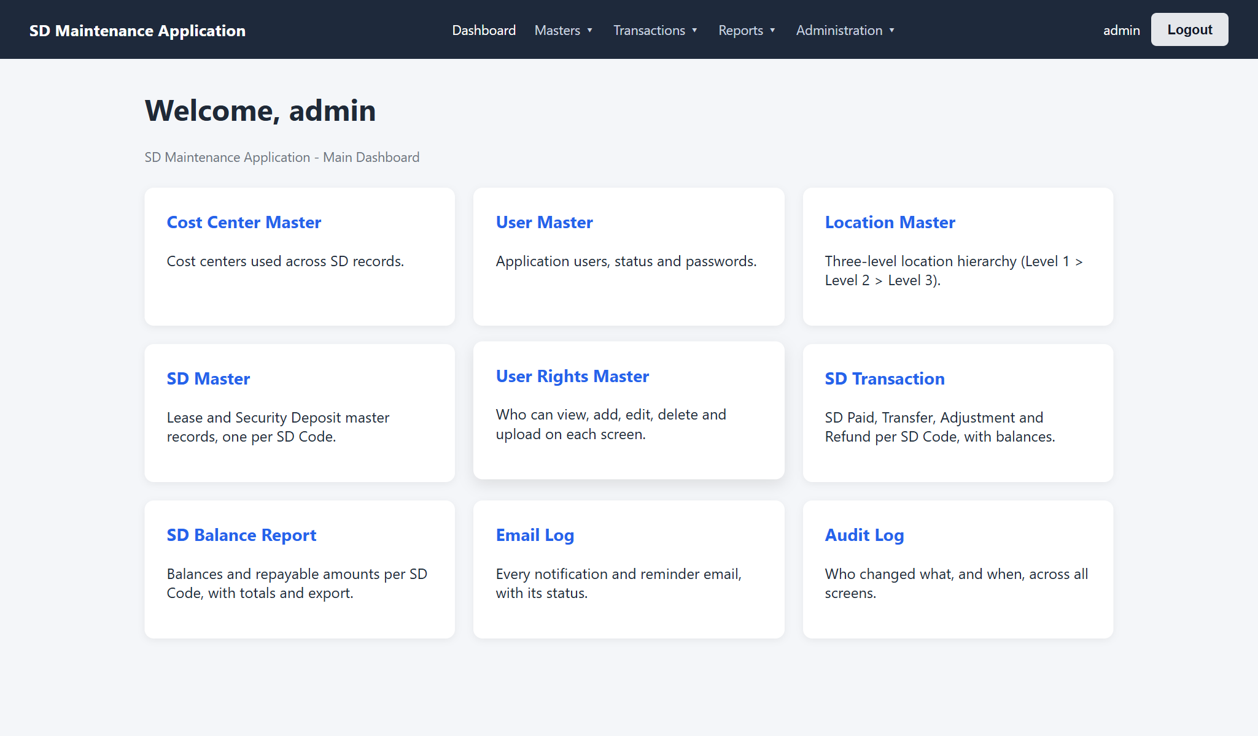
Figure 2: Dashboard (administrator)
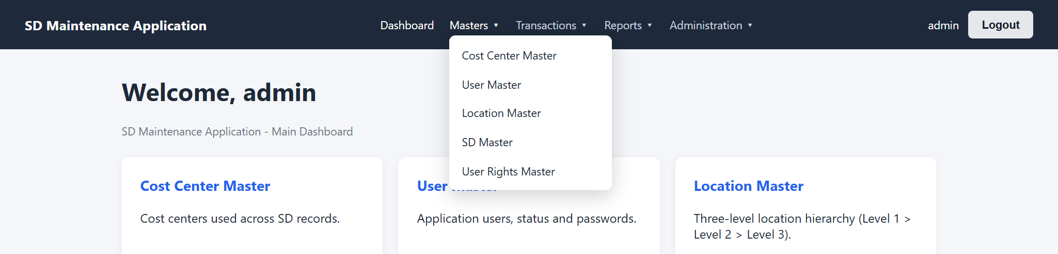
Figure 3: Menu bar with the Masters menu open
Menu | Screen | Used for
Masters | Cost Center Master | Cost centers used on SD records
Masters | User Master | Application users, status and passwords
Masters | Location Master | Location hierarchy: Level 1 > Level 2 > Level 3
Masters | SD Master | Lease and Security Deposit master records
Masters | User Rights Master | Who can view, add, edit, delete and upload on each screen
Transactions | SD Transaction | SD Paid, Transfer, Adjustment and Refund, with balances
Reports | SD Balance Report | Balances per SD Code with totals
Administration | Email Log, Audit Log | Notifications sent, and every change made
Administration | User Profile, Change Password, Logout | Your own account

2.4 What you can see and do
Your administrator gives you rights per screen. Screens you have no right to are hidden from your menu and Dashboard, and buttons such as Add, Edit, Delete or Upload appear only if you have that right.
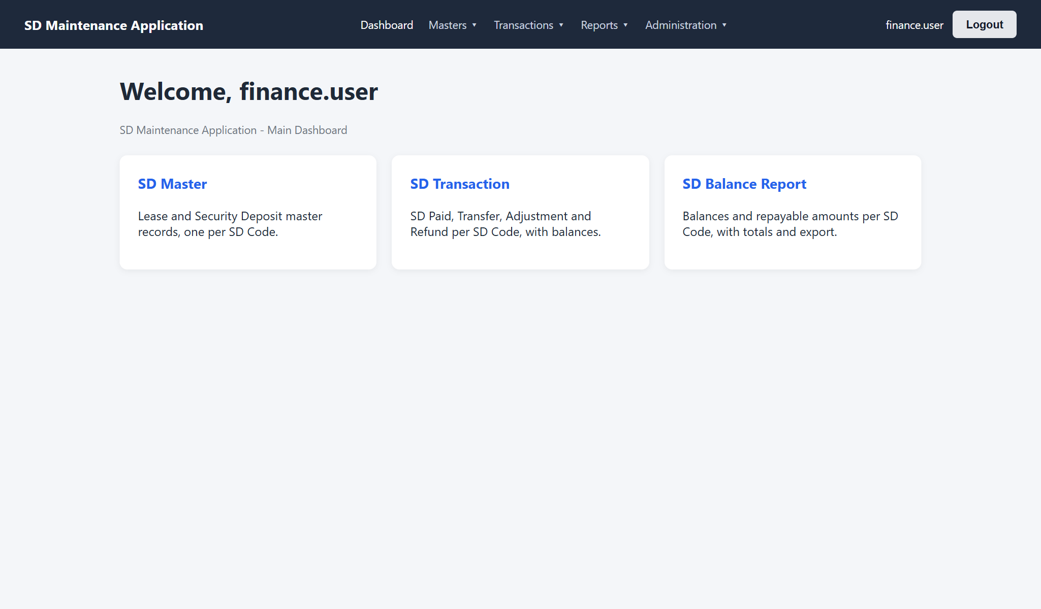
Figure 4: Dashboard of a user with rights on SD Master, SD Transaction and the report only
If you open a screen you are not allowed to use (for example from a saved link), you see an Access denied message.
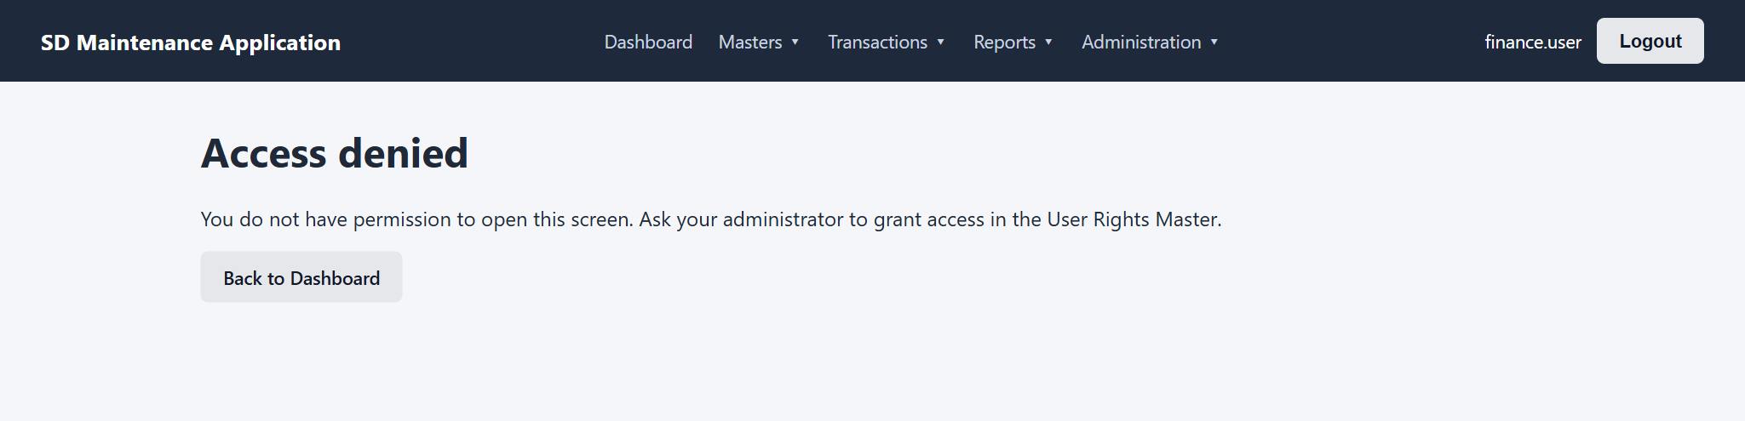
Figure 5: Access denied

2.5 User Profile and Change Password
Administration > User Profile shows your details and exactly which rights you have on each screen.
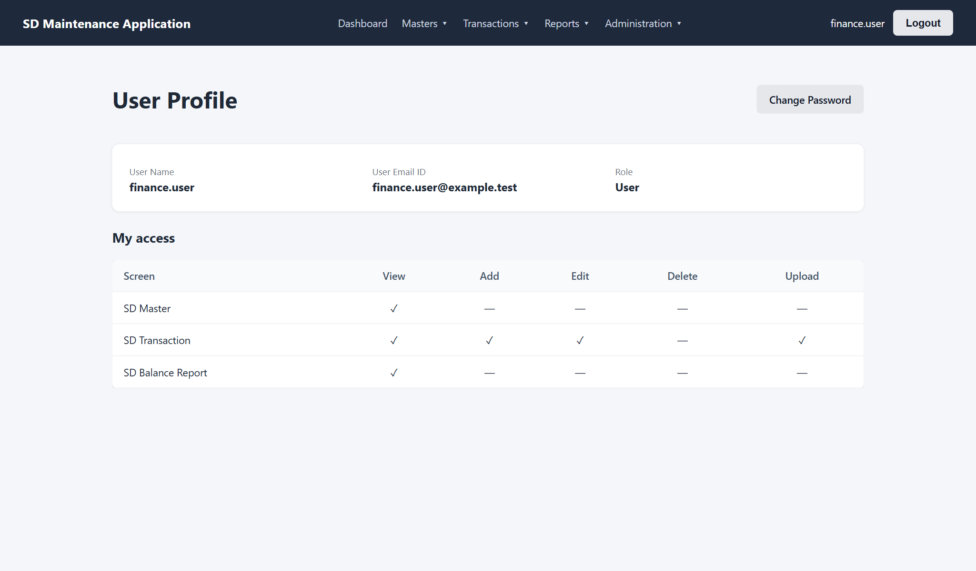
Figure 6: User Profile with the user's rights
To change your password, open Administration > Change Password, enter your current password and the new one twice, and click Change Password.
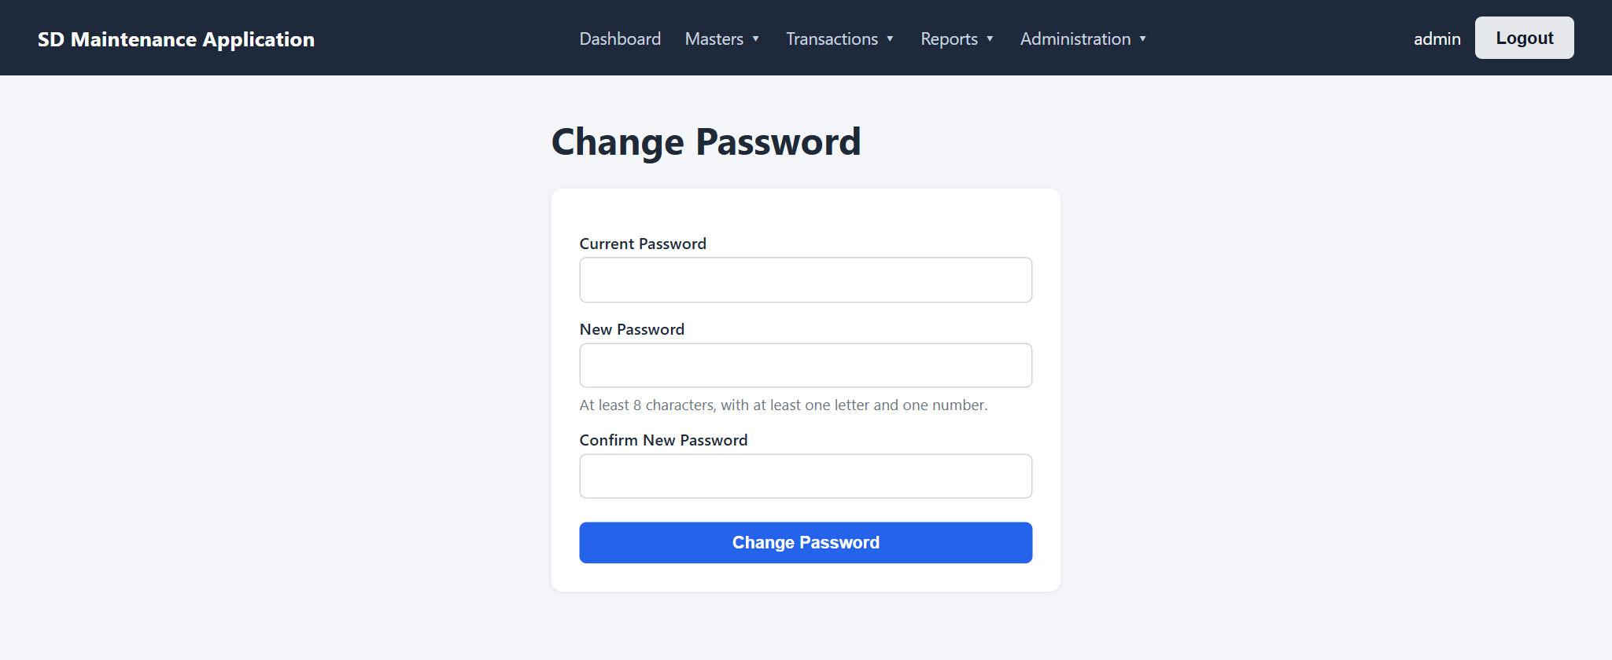
Figure 7: Change Password
Note: Changing your password signs you out on every other computer or browser. The one you are using stays signed in.

2.6 Logging out and automatic logout
- Click Logout at the top right (or Administration > Logout). This ends your sessions on all devices.
- You are logged out automatically after 30 minutes without activity. Unsaved changes on an open form are lost.
- If an administrator deactivates your account or resets your password, you are signed out straight away.

3. Working with Screens
Most screens share the same layout: a title with an Add button, an Excel upload panel, a filter bar, and a table of records with Edit and Delete buttons.

3.1 Search, filters and pages
- Type in the search box; the list updates as you type (codes, names and other key fields are searched).
- Use the drop-down filters (status, cost center, location and so on) to narrow the list. Clear resets all filters.
- Long lists show 50 rows per page. Use Previous and Next below the table.

3.2 Adding, editing and deleting
- Click the + Add button at the top right, fill in the form and click Save.
- To change a record, click Edit on its row, make the change and click Save.
- To remove a record, click Delete and confirm.
If a save fails, the form lists every problem at once; fix them and save again.
Important: Records that are in use cannot be deleted - for example a cost center or location used by an SD record, an SD record with transactions, or a user who has created or changed data. Set them to Inactive instead. Inactive values stay on existing records but cannot be chosen for new ones.

3.3 Exporting to Excel
Click Export to Excel to download the records that match your current search and filters (all pages, not only the page on screen).

3.4 Uploading records from Excel
Every master and the SD Transaction screen can load many records at once from an Excel file.
- Click Download Template to get an Excel file with the correct column headings.
- Fill in one record per row below the headings. Do not rename or remove columns.
- Save the file as an Excel Workbook (.xlsx). The older .xls format is not accepted.
- Click Choose File, select your file and click Upload & Validate.
- Read the validation result. Valid rows are saved; failed rows are not.
- Correct the failed rows in your file, delete the rows that were saved, and upload again.
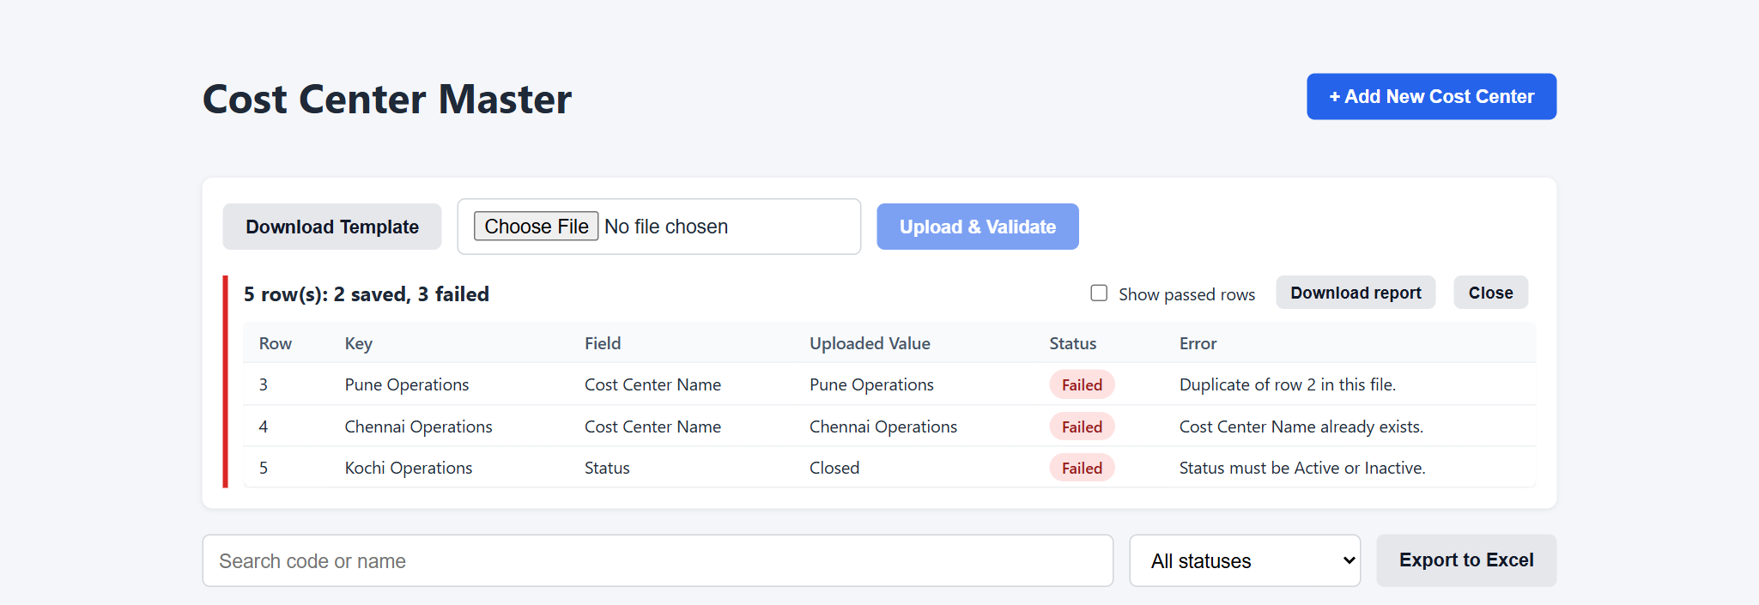
Figure 8: Validation result after an upload: 2 rows saved, 3 failed
Column | Meaning
Row | Row number in your Excel file (row 1 is the heading row)
Key | Which record the row is about (for example the SD Code or name)
Field | The column with the problem
Uploaded Value | What the file contained
Status | Passed or Failed
Error | What is wrong and what is expected

- Tick Show passed rows to see the saved rows as well.
- Download report saves the result as Excel, which is useful for correcting large files.
- A row can fail because it repeats another row in the same file, as well as because the value already exists.
- If the file is missing a required column, or is not an .xlsx file, nothing is saved and a message explains why.

3.5 Bulk updates
SD Master and SD Transaction uploads can also update existing records:
- SD Master: fill in the SD Code column. Leave SD Code blank to create a new record.
- SD Transaction: fill in the Transaction No. column. Leave it blank to add a new transaction.
- On an update row, only the cells you fill in are changed. Blank cells keep their current value.
Tip: Export the records first. The export has the same columns as the template, so you can change values in it and upload it back as a bulk update.

4. Masters

4.1 Cost Center Master
Maintains the cost centers that SD records are assigned to.
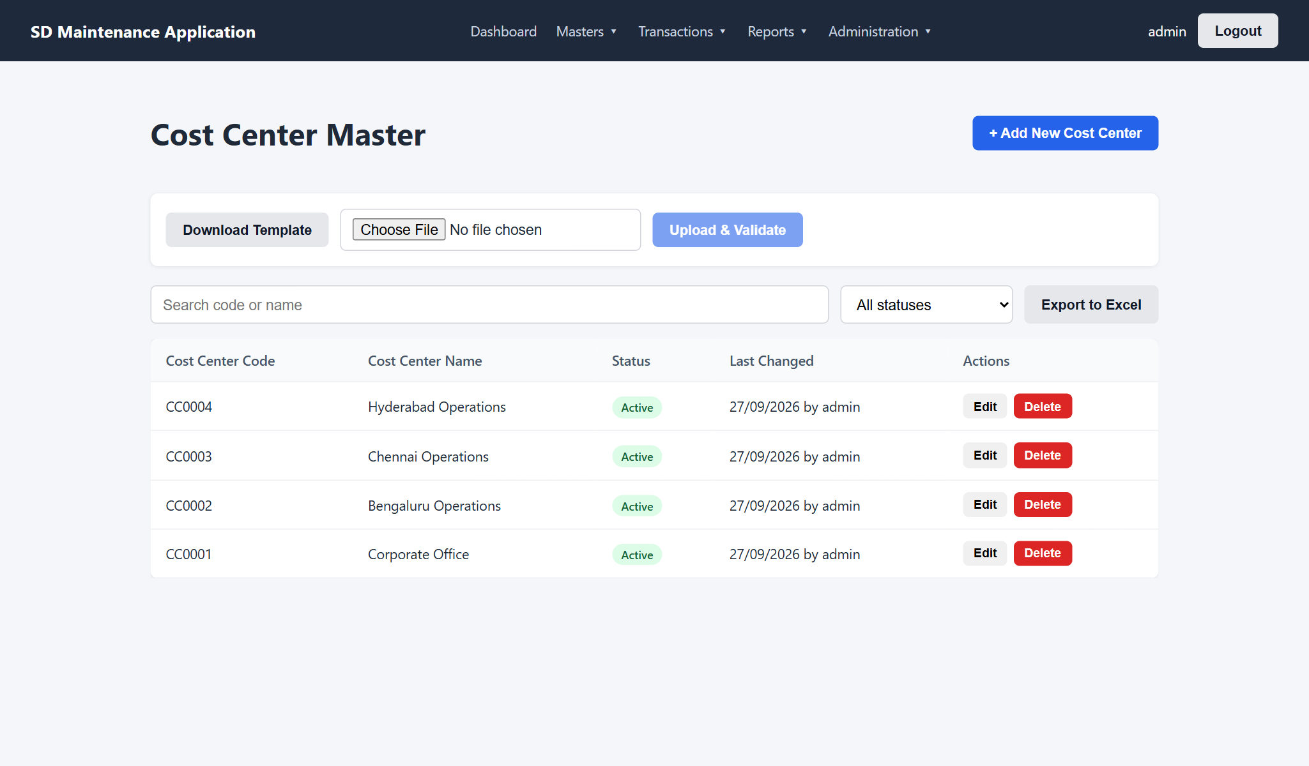
Figure 9: Cost Center Master
Field | Required | Rules
Cost Center Code | Automatic | Generated on save (CC0001, CC0002 ...). Cannot be changed.
Cost Center Name | Yes | Unique (capital and small letters are treated the same). Up to 150 characters.
Status | Yes | Active or Inactive. Only Active cost centers can be chosen on new SD records.

Upload columns: Cost Center Name, Status (blank means Active).

4.2 Location Master
Locations have three levels, for example State > City > Site. Each level has its own tab.
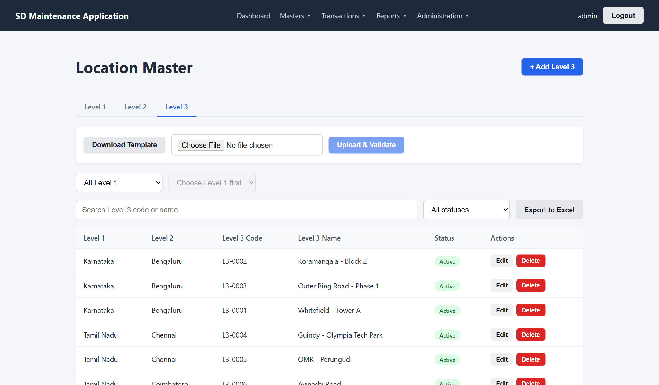
Figure 10: Location Master, Level 3 tab
Level | Belongs to | Name must be unique
Level 1 | - | Across all Level 1 records
Level 2 | A Level 1 | Within its Level 1 (the same city name can exist under two states)
Level 3 | A Level 2 (and its Level 1) | Within its Level 2

Adding a Level 3 location
- Open the Level 3 tab and click + Add Level 3.
- Choose the Level 1. The Level 2 list then shows only that Level 1's records.
- Choose the Level 2, type the Level 3 Name, and click Save.
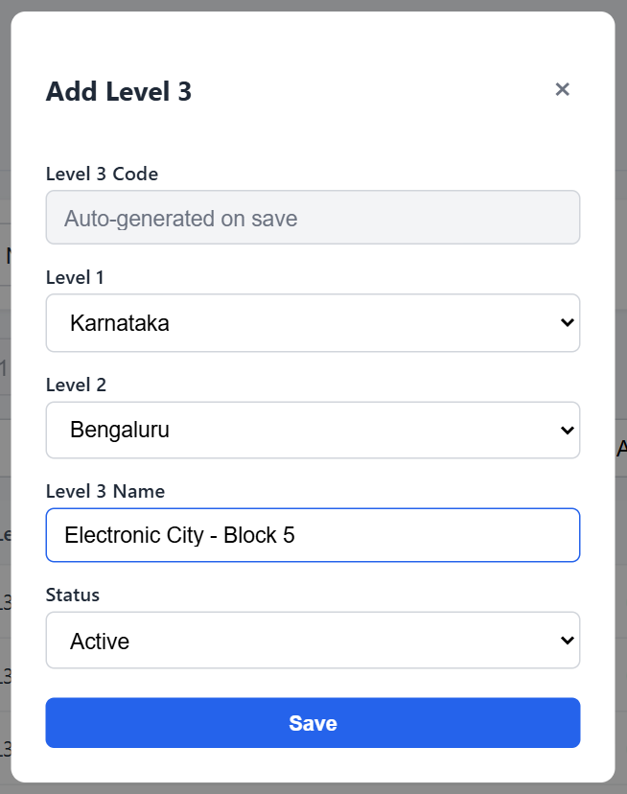
Figure 11: Adding a Level 3 location
- Only Active parents can be chosen.
- A location with records under it, or used by an SD record, cannot be deleted - make it Inactive.
- Moving a Level 2 to another Level 1 moves its Level 3 records, and the SD records that use them, along with it.
- Uploads match parents by name, so upload Level 1 first, then Level 2, then Level 3.

4.3 User Master
Administrators create and maintain user accounts here.
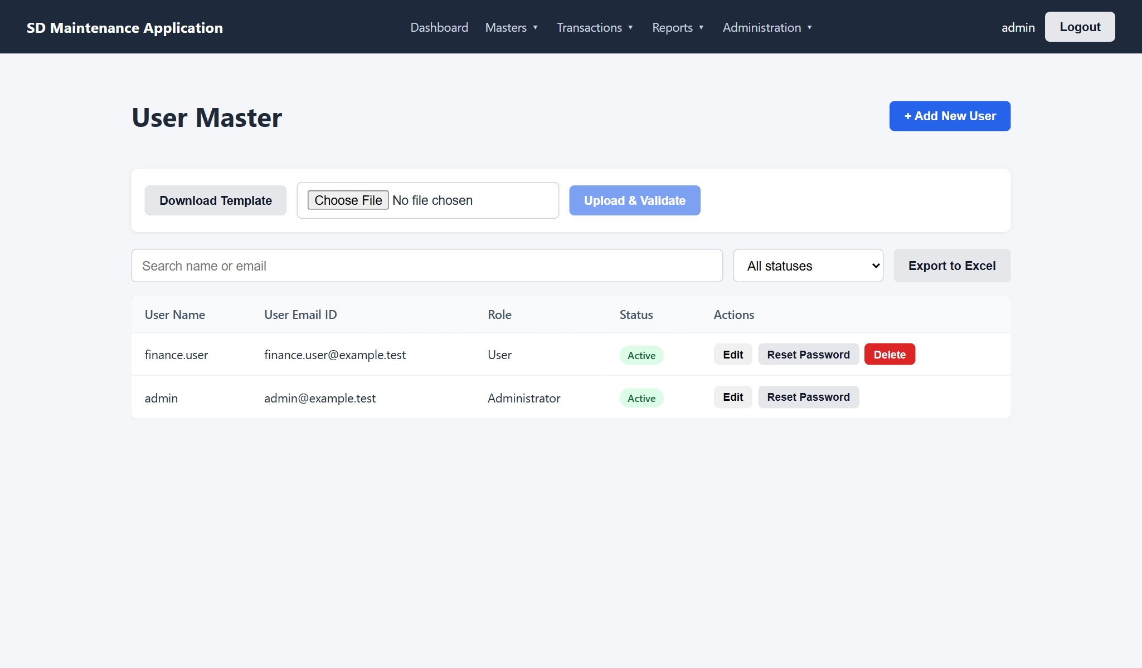
Figure 12: User Master
- Add New User: User Name and User Email ID must both be unique. Set a starting password that meets the password rule.
- A new user has no access until rights are given in the User Rights Master.
- Reset Password sets a new password for the user and signs them out everywhere.
- Set Status to Inactive to stop someone logging in. Their history is kept.
- Users who have created or changed any records cannot be deleted - make them Inactive. The administrator account cannot be deactivated or deleted.
Upload columns: User Name, User Email ID, Password (optional; a default password is given if blank), Status.

4.4 User Rights Master
Controls what each user can see and do on every screen.
- Search for the user in the list on the left and click their name.
- Tick the rights for each screen. All and None set a whole row.
- Click Save Rights. Use Undo changes to go back to the last saved rights.
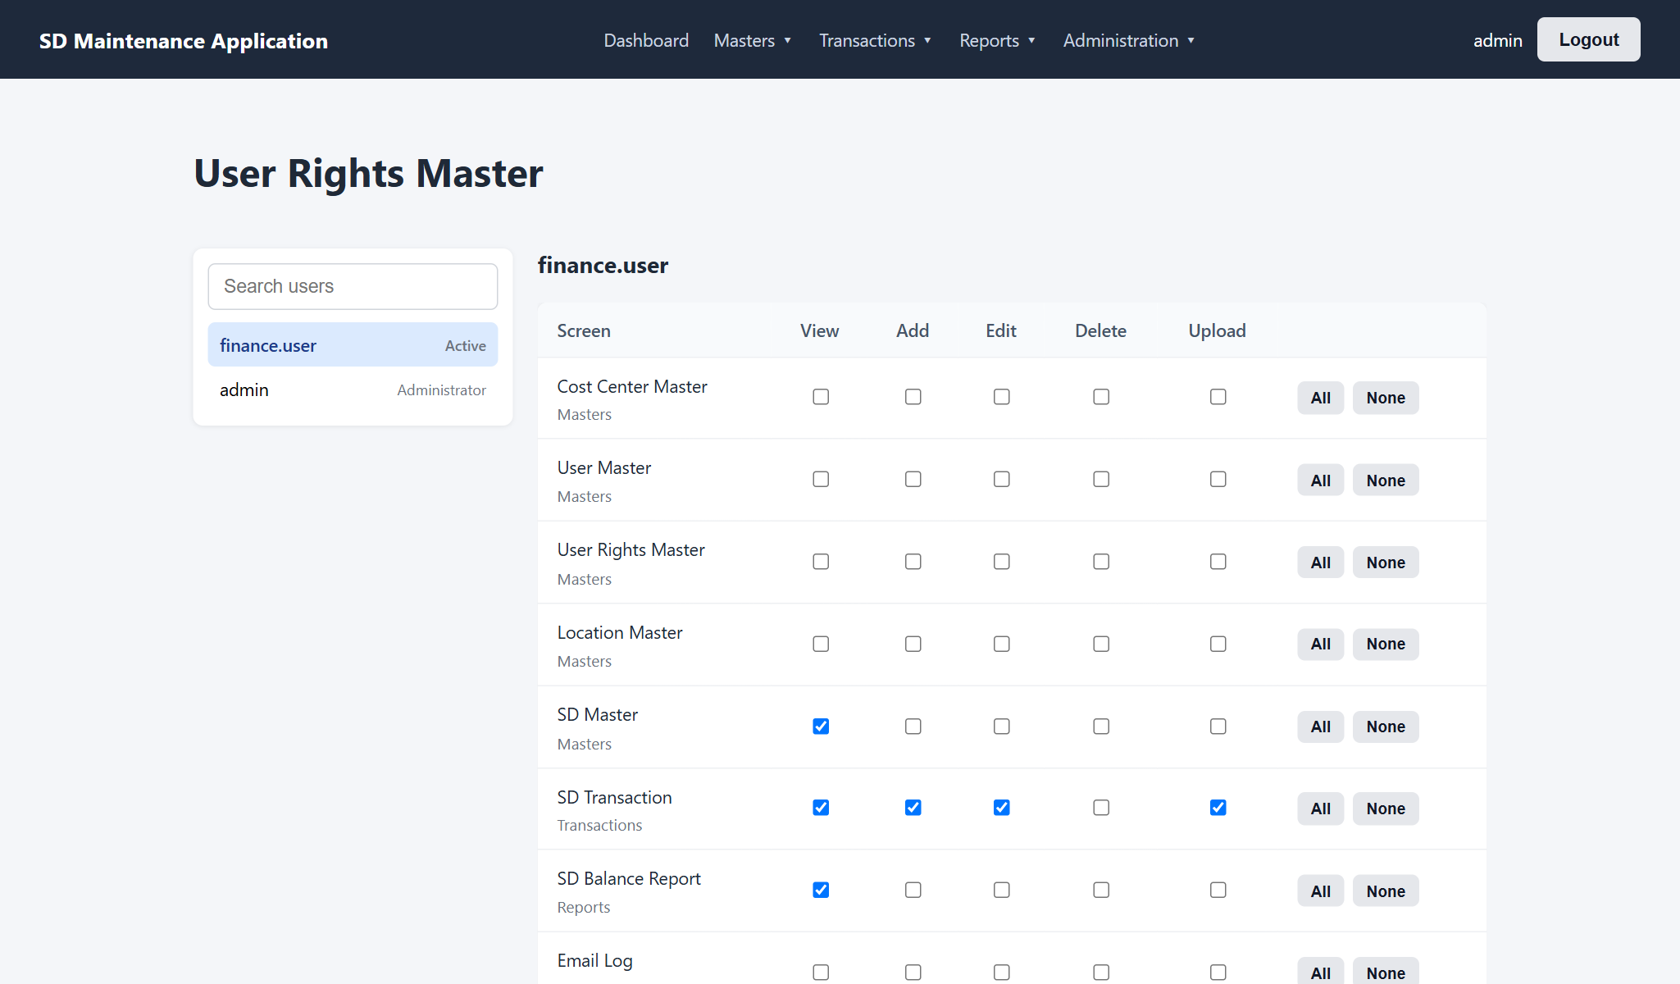
Figure 13: Rights of a finance user
Right | Allows the user to
View | Open the screen, search, filter and export
Add | Create new records
Edit | Change records (and reset passwords, on User Master)
Delete | Delete records that are not in use
Upload | Download templates and upload Excel files

- Any right on a screen includes View; removing View removes all rights on that screen.
- Administrators always have every right; their rights cannot be edited.
- Changes apply from the user's next action; they do not need to log in again.

4.5 SD Master
One SD record per lease, identified by its SD Code. SD transactions are recorded against the SD Code.
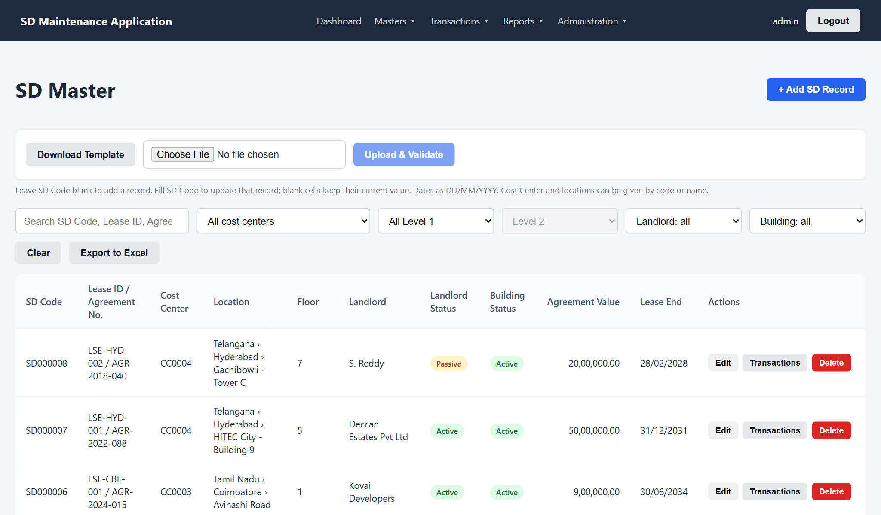
Figure 14: SD Master list
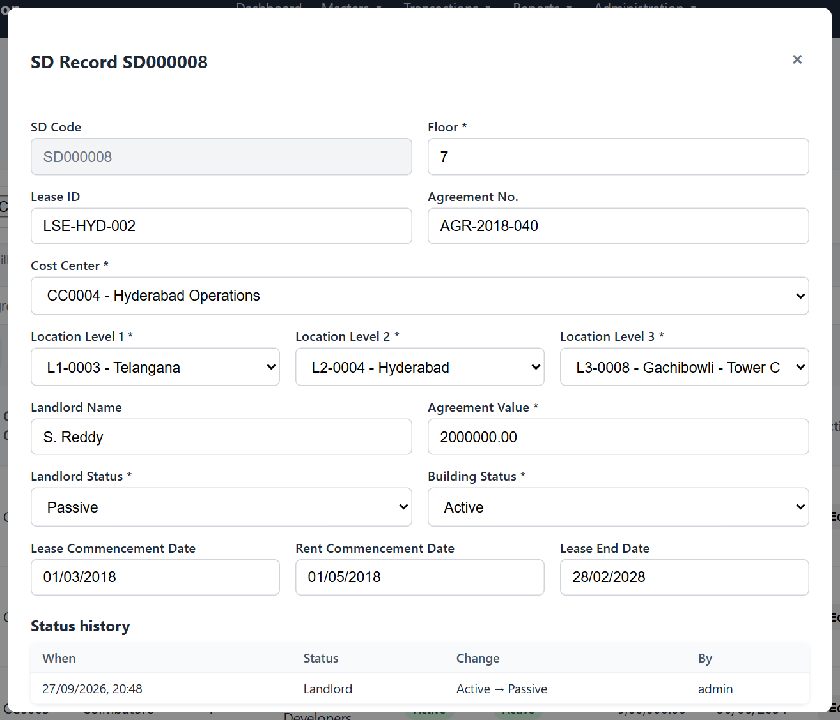
Figure 15: SD record form
Field | Required | Rules
SD Code | Automatic | Generated on save (SD000001 ...). Used for transactions, bulk updates and reports.
Lease ID, Agreement No. | No | Up to 50 characters each.
Cost Center | Yes | Active cost center.
Location Level 1, 2, 3 | Yes | Active locations; Level 2 must belong to Level 1, and Level 3 to Level 2.
Landlord Name | No | Up to 200 characters.
Landlord Status, Building Status | Yes | Active or Passive.
Floor | Yes | Text, for example Ground or 4.
Agreement Value | Yes | Greater than zero, up to 2 decimals. Cannot be lowered below the total SD Paid.
Lease Commencement, Rent Commencement, Lease End Date | No | DD/MM/YYYY. Lease End cannot be before Lease Commencement.

Note: Lease ID + Agreement No. + Floor must be unique. The check applies when Lease ID or Agreement No. is filled in.

Landlord and Building Status
When either status changes from Active to Passive:
- existing transactions stay visible and can still be corrected;
- no new transactions can be added for the SD Code;
- an email is sent to the SD notification mailbox;
- the change is recorded in the record's Status history, shown at the bottom of its form.
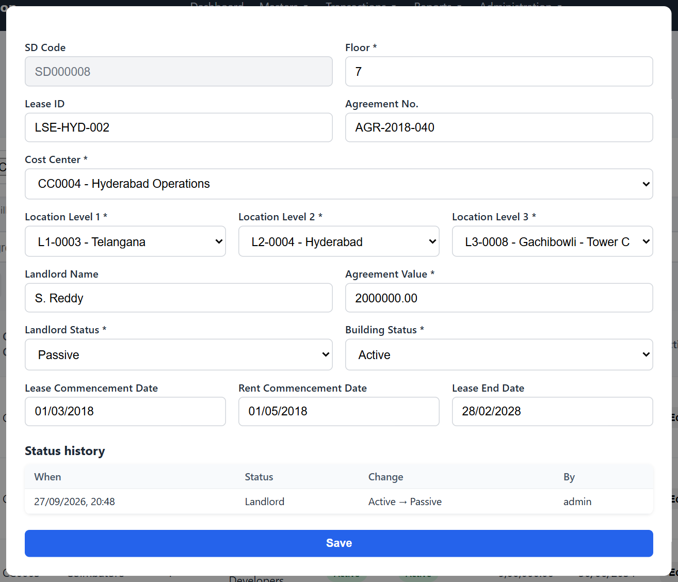
Figure 16: Status history of an SD record
Each row has a Transactions button that opens the SD Transaction screen for that SD Code. Users with View but not Edit rights see a View button and a read-only form.
Upload: see Appendix A. Cost Center and locations can be given by code or by name.

5. SD Transactions

5.1 Opening an SD Code
Type part of an SD Code, Lease ID, Agreement No. or landlord name in the search box and pick the SD Code from the list (or use the Transactions button in SD Master). The screen then shows:
- the SD Master details (read-only) and the Landlord and Building Status;
- totals: Agreement Value, Paid, Transfer, Adjustment, Refund, SD Balance and SD Balance Repayable;
- every transaction of the SD Code, oldest first, with running balances.
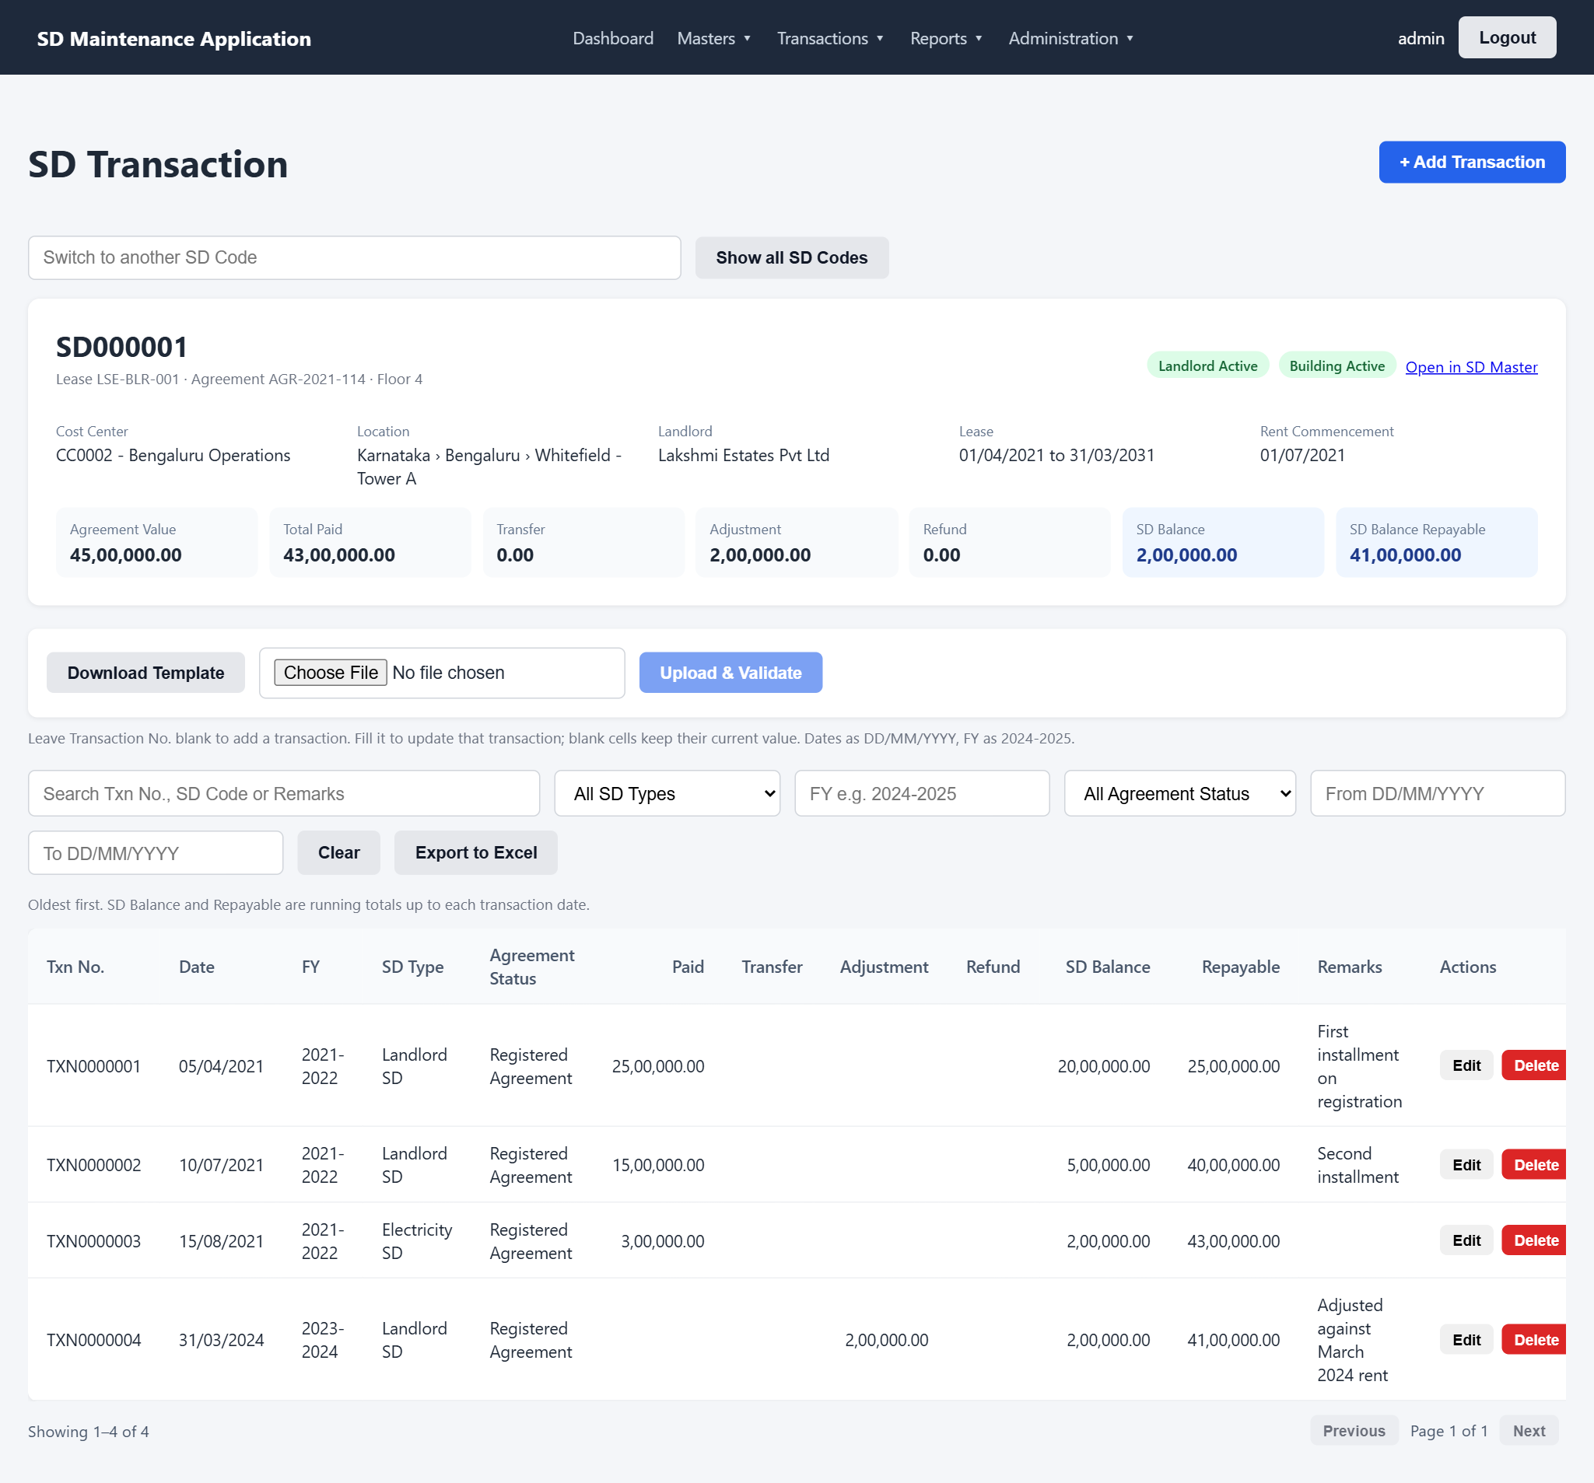
Figure 17: SD Transaction screen for one SD Code

5.2 How balances are calculated
Value | Formula
SD Balance | Agreement Value - Total SD Paid
SD Balance Repayable | Total SD Paid - Total SD Transfer - Total SD Refund - Total SD Adjustment

Both are calculated automatically, in transaction-date order, and cannot be typed in. The running columns show the value up to and including each transaction. Example for SD000001 (Agreement Value 45,00,000.00):
Date | Transaction | SD Balance | Repayable
05/04/2021 | Paid 25,00,000.00 | 20,00,000.00 | 25,00,000.00
10/07/2021 | Paid 15,00,000.00 | 5,00,000.00 | 40,00,000.00
15/08/2021 | Paid 3,00,000.00 (Electricity SD) | 2,00,000.00 | 43,00,000.00
31/03/2024 | Adjustment 2,00,000.00 | 2,00,000.00 | 41,00,000.00

5.3 Adding a transaction
- Open the SD Code and click + Add Transaction.
- Enter the SD Transaction Date. FY fills in automatically (April-March); change it if needed.
- Choose the SD Type and Agreement Status.
- Enter at least one amount: SD Paid, Transfer, Adjustment or Refund.
- Add Remarks if useful (for a transfer, note the receiving SD Code) and click Save.
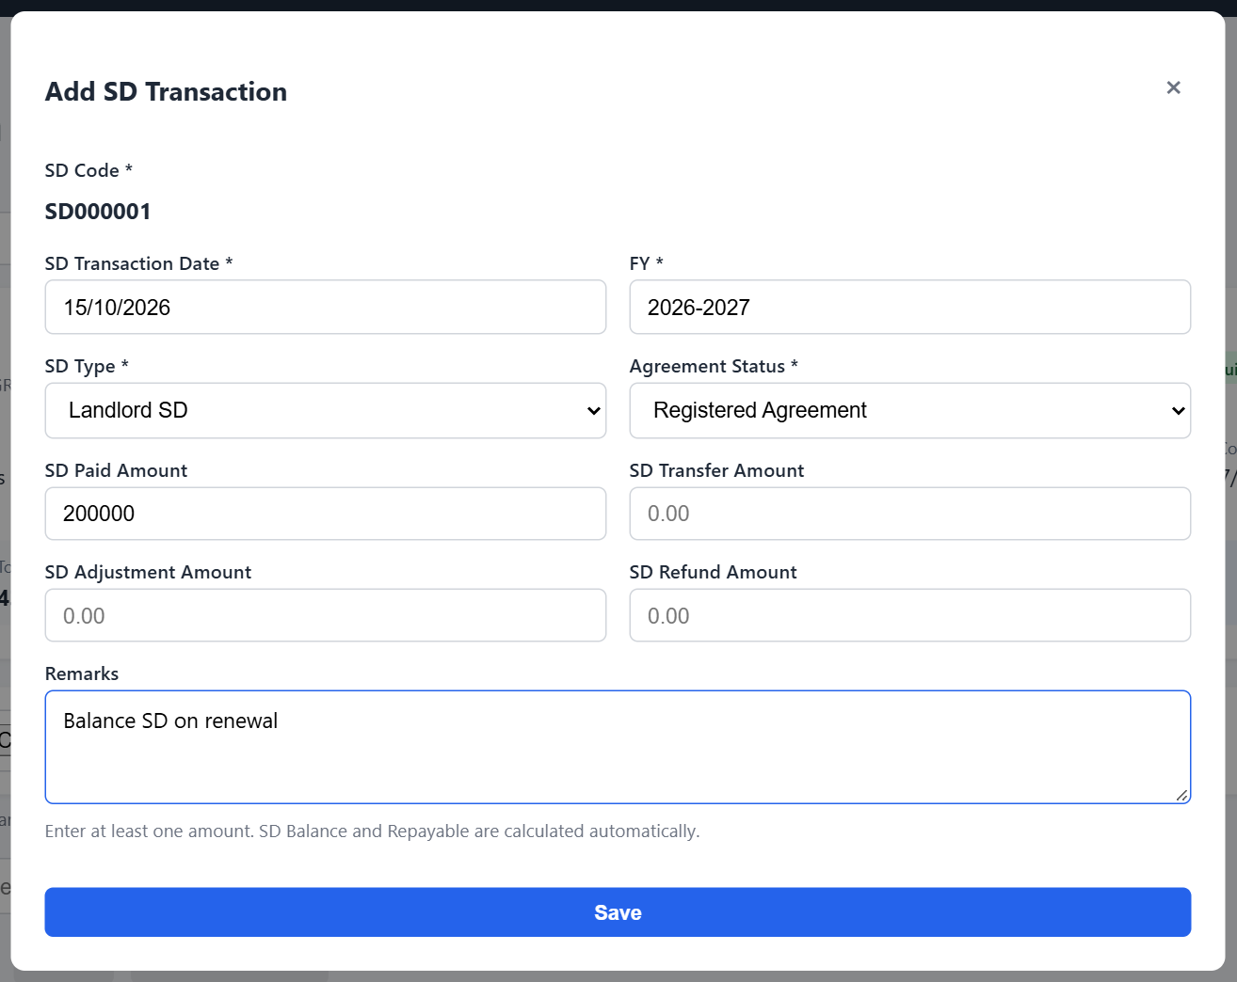
Figure 18: Add SD Transaction form
Field | Required | Rules
SD Type | Yes | Landlord SD, Electricity SD, Additional Parking SD, Other SD, Fitout SD, CAM SD, Solar SD
FY | Yes | Two consecutive years, for example 2024-2025
SD Transaction Date | Yes | DD/MM/YYYY
Agreement Status | Yes | LOI, Agreement, Registered Agreement, Addendum Agreement, Mail Approval
SD Paid / Transfer / Adjustment / Refund Amount | At least one | Zero or more, up to 2 decimals
Remarks | No | Up to 1000 characters

5.4 Rules checked on every save
- Total SD Paid cannot exceed the Agreement Value. To record more, first increase the Agreement Value in SD Master.
- SD Balance Repayable cannot fall below zero on any date. Transfers, adjustments and refunds cannot be dated before the payments they relate to.
- Passive SD Codes (Landlord or Building Status Passive) cannot take new transactions.
- A transfer reduces only this SD Code. Record the receiving SD Code in Remarks and, if needed, add a Paid transaction on the receiving SD Code.
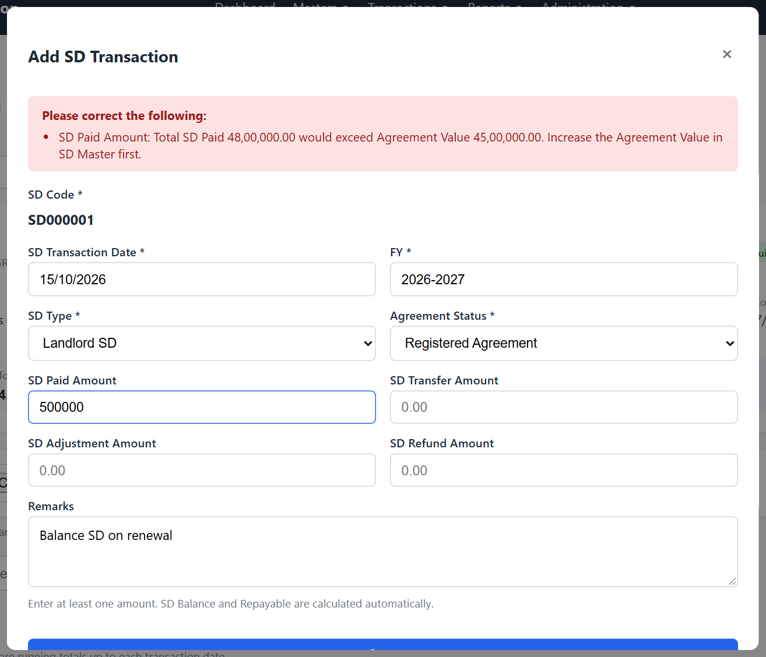
Figure 19: A payment that would exceed the Agreement Value is refused

5.5 Editing and deleting
Use Edit or Delete on a transaction row. The same rules apply: for example, a payment cannot be deleted if a later refund depends on it. A transaction always stays on its SD Code; to move it, delete it and add it on the correct SD Code.

5.6 Viewing all transactions
Click Show all SD Codes (or open the screen without choosing an SD Code) to list transactions across all SD Codes, newest first. Filter by SD Type, FY, Agreement Status or a date range, and export the result.
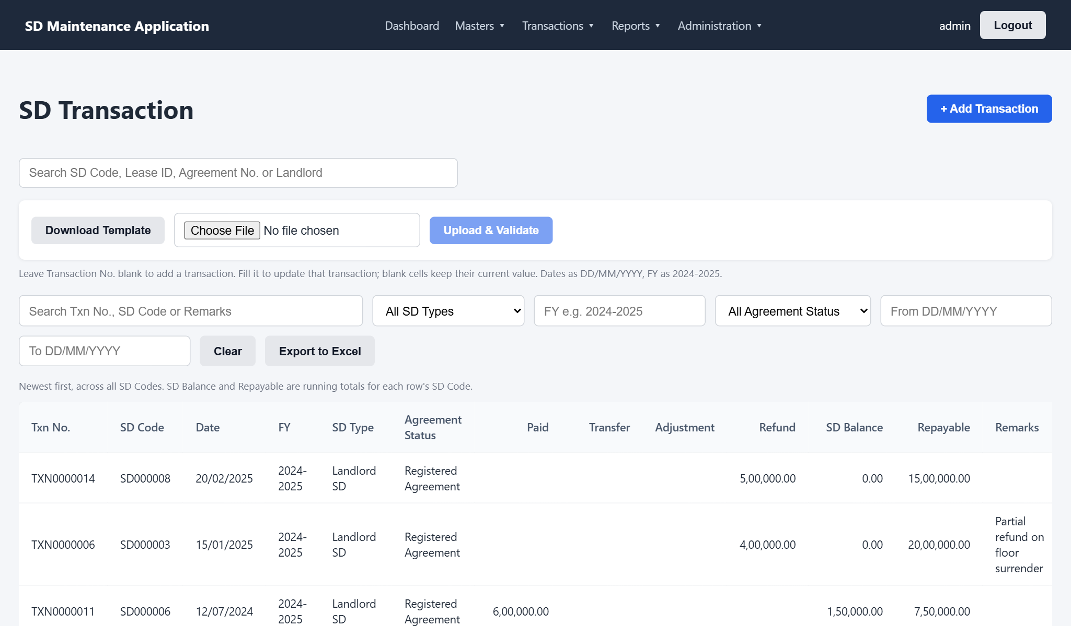
Figure 20: Transactions across all SD Codes

5.7 Uploading transactions
Use the transaction template (Appendix A). Rows for the same SD Code are checked in file order together with its saved transactions, so if one row would take the SD Code over its limits, only that row fails.

6. Reports

6.1 SD Balance Report
Reports > SD Balance Report shows one row per SD Code with Agreement Value, totals of Paid, Transfer, Adjustment and Refund, SD Balance, SD Balance Repayable and the number of transactions. The tiles above the table total all rows that match your filters.
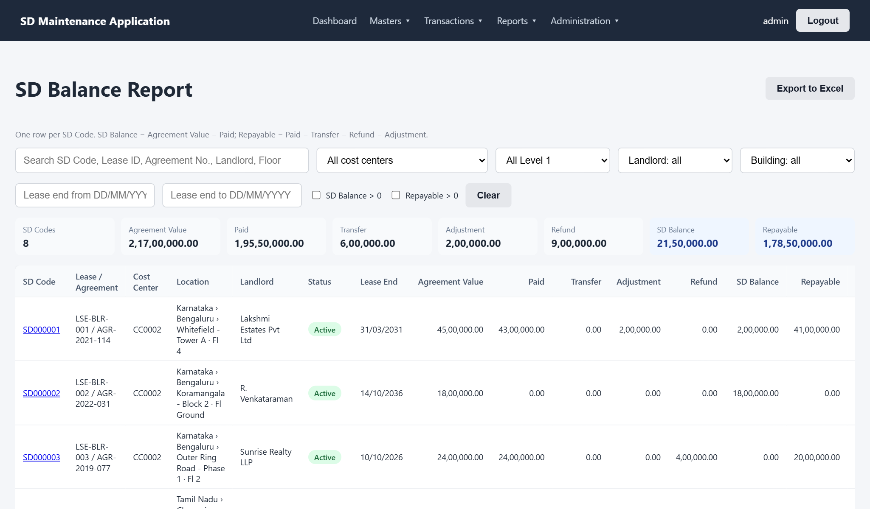
Figure 21: SD Balance Report
- Filter by cost center, Level 1 location, Landlord or Building Status, and a Lease End date range (useful for upcoming expiries).
- Tick SD Balance > 0 to see SD Codes not yet fully paid, or Repayable > 0 to see deposits still to be recovered.
- Click an SD Code to open its transactions.
- Export to Excel includes a TOTAL row at the bottom.

7. Administration

7.1 Email notifications
The application emails the SD notification mailbox configured by IT:
Notification | Sent when
Landlord Status changed to Passive | Immediately after an SD record is saved or uploaded with Landlord Status changed from Active to Passive
Building Status changed to Passive | Same, for Building Status
Lease Commencement reminder | 15 days before the Lease Commencement Date
Rent Commencement reminder | 15 days before the Rent Commencement Date
Lease End reminder | 15 days before the Lease End Date

- Reminders are sent by a daily job and include the SD record's details. Each reminder is sent once.
- If the system was unavailable on the day, the reminder is sent at the next run (still before the date).
- Reminders are not sent for Passive SD Codes.

7.2 Email Log
Administration > Email Log lists every email with its date and time, SD Code, type, recipient, subject, trigger and status. Filter by type, status or date and export if needed.
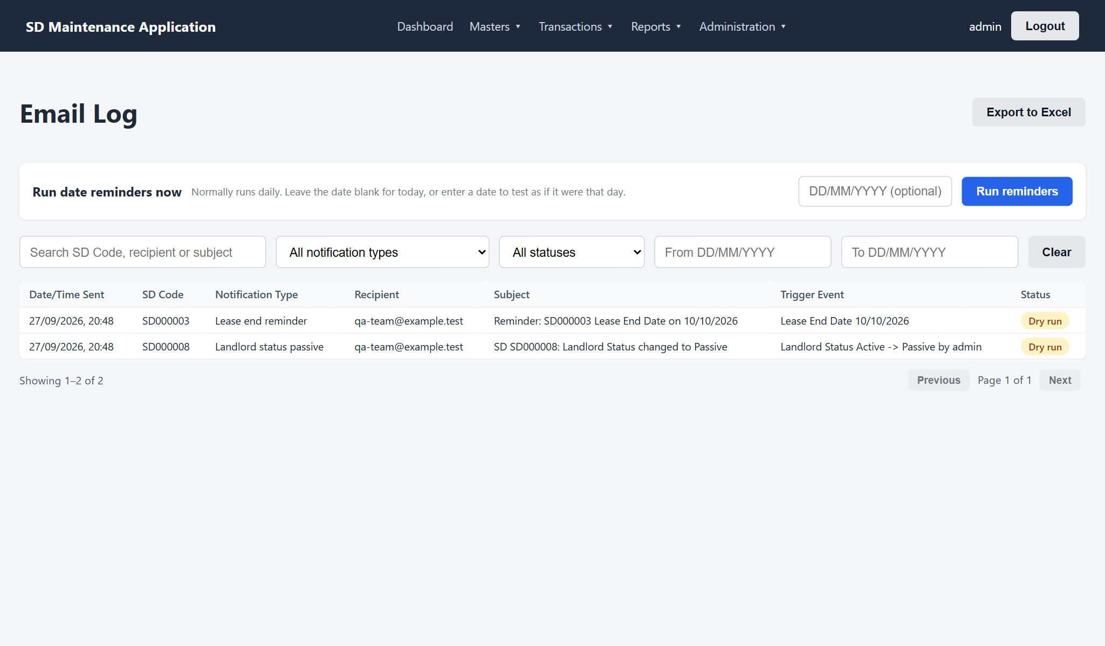
Figure 22: Email Log
Status | Meaning
Sent | Delivered to the mail server
Failed | Could not be sent; the reason is shown under the status. Reminders are retried at the next run.
Dry run | Test and UAT systems: the email was prepared and logged but deliberately not sent

Administrators can click Run reminders to run the daily reminder job immediately. Entering a date runs it as if that date were today, which lets UAT testers check reminders without waiting.

7.3 Audit Log
Administration > Audit Log records every add, edit, delete, upload, status change, rights change, login, logout and password change, with who did it and when. Changed fields are shown with their old and new values; Values shows the full record before and after.
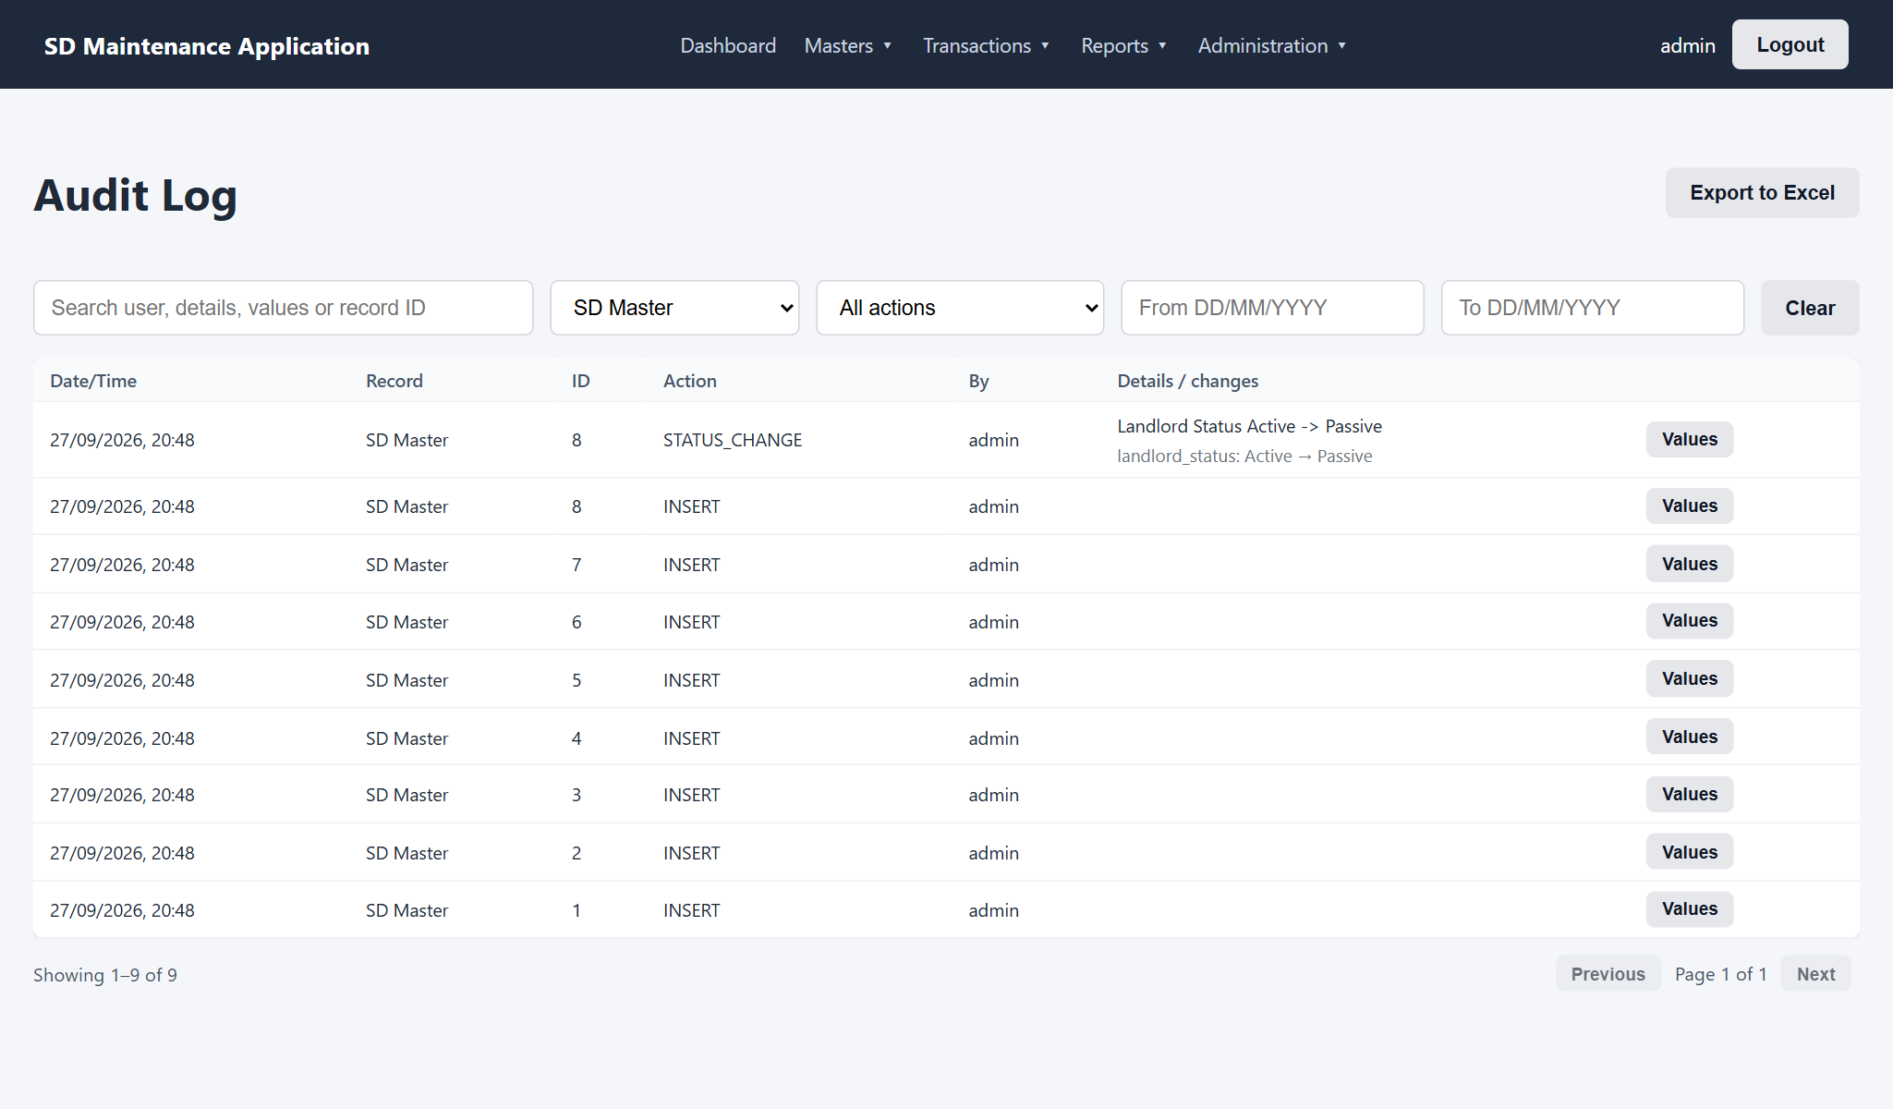
Figure 23: Audit Log filtered to SD Master records
Search by user name, record ID or any value, and filter by record type, action and date.

8. Troubleshooting
Message | What it means / what to do
Invalid User Name or Password | Check both and try again. Use Forgot Password if needed.
Your account is inactive | Your account was deactivated. Contact the administrator.
Session expired. Please log in again | You were idle for 30 minutes, logged out elsewhere, or your password was changed. Log in again.
Access denied / screen missing from the menu | You do not have View rights on that screen. Ask the administrator.
... already exists | A record with the same name or key exists. Search for it and edit it instead.
... is Inactive | The chosen master is Inactive. Choose an Active one, or ask for it to be reactivated.
Cannot be deleted ... Mark it Inactive instead | The record is in use. Set its status to Inactive.
Total SD Paid ... would exceed Agreement Value | Increase the Agreement Value in SD Master first, or correct the amount.
SD Balance Repayable would be ... on DD/MM/YYYY | A transfer, adjustment or refund is larger than what was paid by that date. Check the dates and amounts.
... is Passive and cannot take new transactions | Landlord or Building Status is Passive. Change the status in SD Master if the lease is active again.
The file is missing required column(s) | Download the latest template and copy your data into it.
Only .xlsx files are allowed | In Excel use File > Save As > Excel Workbook (.xlsx).
Date must be a valid date in DD/MM/YYYY format | Type the date as DD/MM/YYYY, for example 05/04/2024, and check the day exists.

Appendix A. Excel Upload Columns
Column headings must match exactly. Download the template from each screen to be sure.

Cost Center Master
Column | Required | Notes
Cost Center Name | Yes | Unique
Status | No | Active (default) or Inactive

User Master
Column | Required | Notes
User Name | Yes | Unique
User Email ID | Yes | Unique, valid email
Password | No | Default password used if blank
Status | No | Active (default) or Inactive

Location Master (one file per level)
Level | Columns
Level 1 | Level 1 Name, Status
Level 2 | Level 1 Name, Level 2 Name, Status
Level 3 | Level 1 Name, Level 2 Name, Level 3 Name, Status

SD Master
Column | New record | Notes
SD Code | Leave blank | Fill in to update that SD record (blank cells keep values)
Lease ID | Optional
Agreement No. | Optional
Cost Center | Required | Code (CC0002) or name
Location Level 1 / 2 / 3 | Required | Code or name; Level 2 within Level 1, Level 3 within Level 2
Landlord Name | Optional
Landlord Status | Required | Active or Passive
Building Status | Required | Active or Passive
Floor | Required
Agreement Value | Required | Number greater than zero
Lease Commencement / Rent Commencement / Lease End Date | Optional | DD/MM/YYYY or an Excel date

SD Transaction
Column | New transaction | Notes
Transaction No. | Leave blank | Fill in to update that transaction (blank cells keep values)
SD Code | Required | Existing SD Code with Active statuses
SD Type | Required | See Appendix B
FY | Required | For example 2024-2025
SD Transaction Date | Required | DD/MM/YYYY or an Excel date
Agreement Status | Required | See Appendix B
SD Paid / Transfer / Adjustment / Refund Amount | At least one | Blank means 0
Remarks | Optional | Up to 1000 characters

Appendix B. Dropdown Values
List | Values
SD Type | Landlord SD, Electricity SD, Additional Parking SD, Other SD, Fitout SD, CAM SD, Solar SD
Agreement Status | LOI, Agreement, Registered Agreement, Addendum Agreement, Mail Approval
Landlord / Building Status | Active, Passive
Master status | Active, Inactive
FY | YYYY-YYYY with consecutive years, for example 2025-2026 (April 2025 to March 2026)

Values in uploads are matched without regard to capital letters (for example "cam sd" is accepted as CAM SD).

